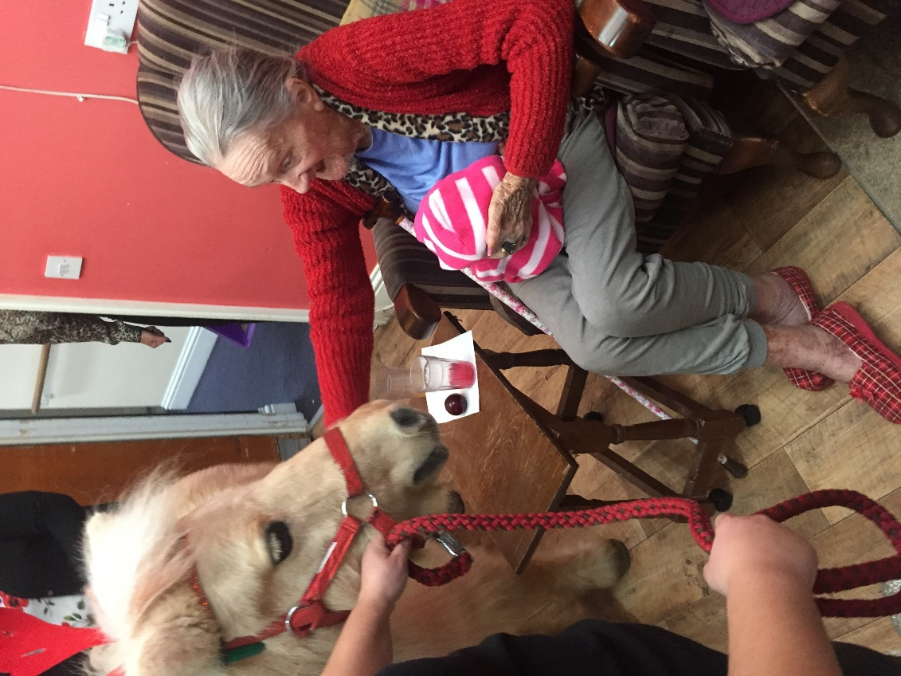

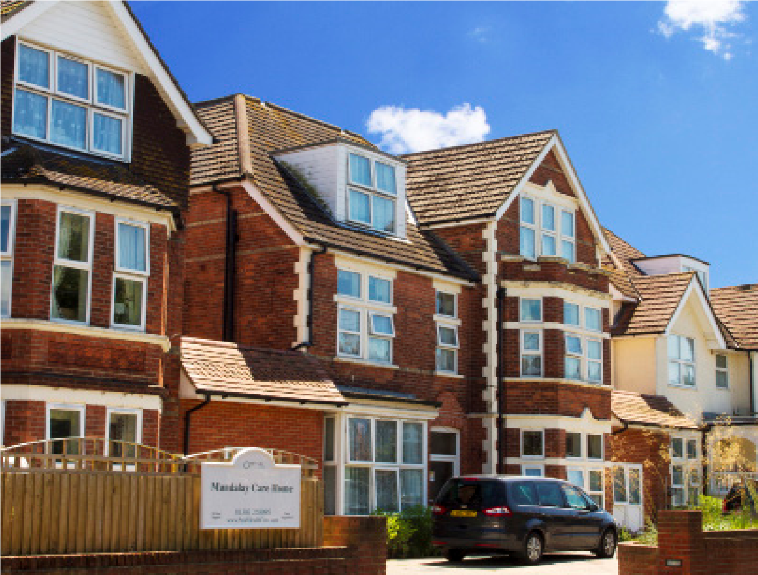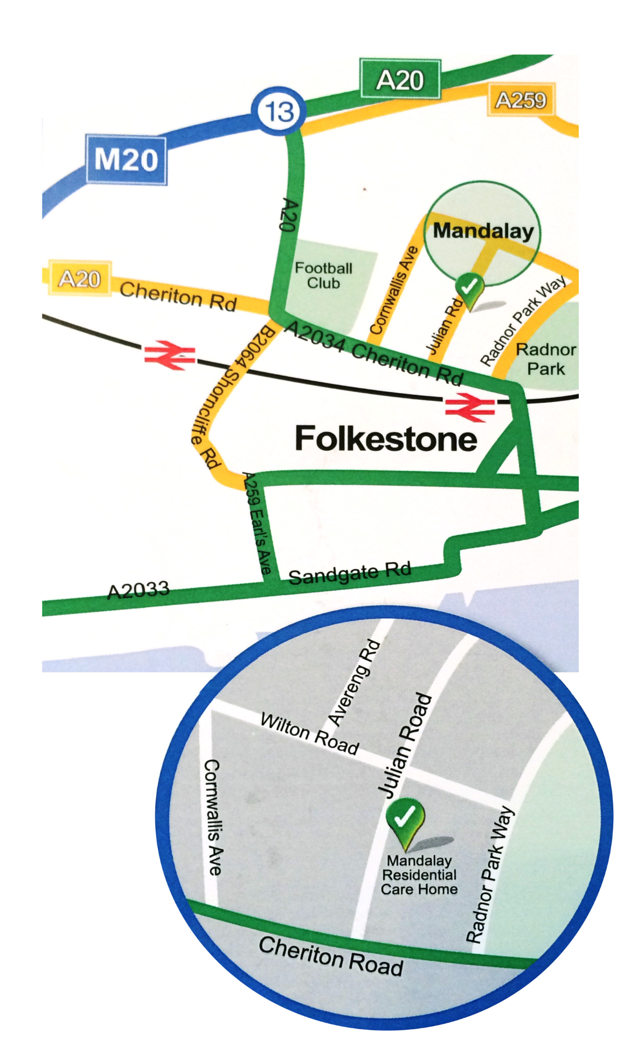

Mandalay

Residential Car

e Home

Folkestone

Individual Care

We recognise that everyone is different and

the care we deliver reflects this. We aim to

create a secure, relaxed, happy and homely

atmosphere for our residents and staff.

Peace of Mind

We are committed to providing the highest

standards of care and service to our residents

and this is achieved through the skills and

determination of our staff.

Mandalay

Residential care home

Call 01303 258095 for further assistance

10-14

Julian Road, Folkestone, CT19 5HP

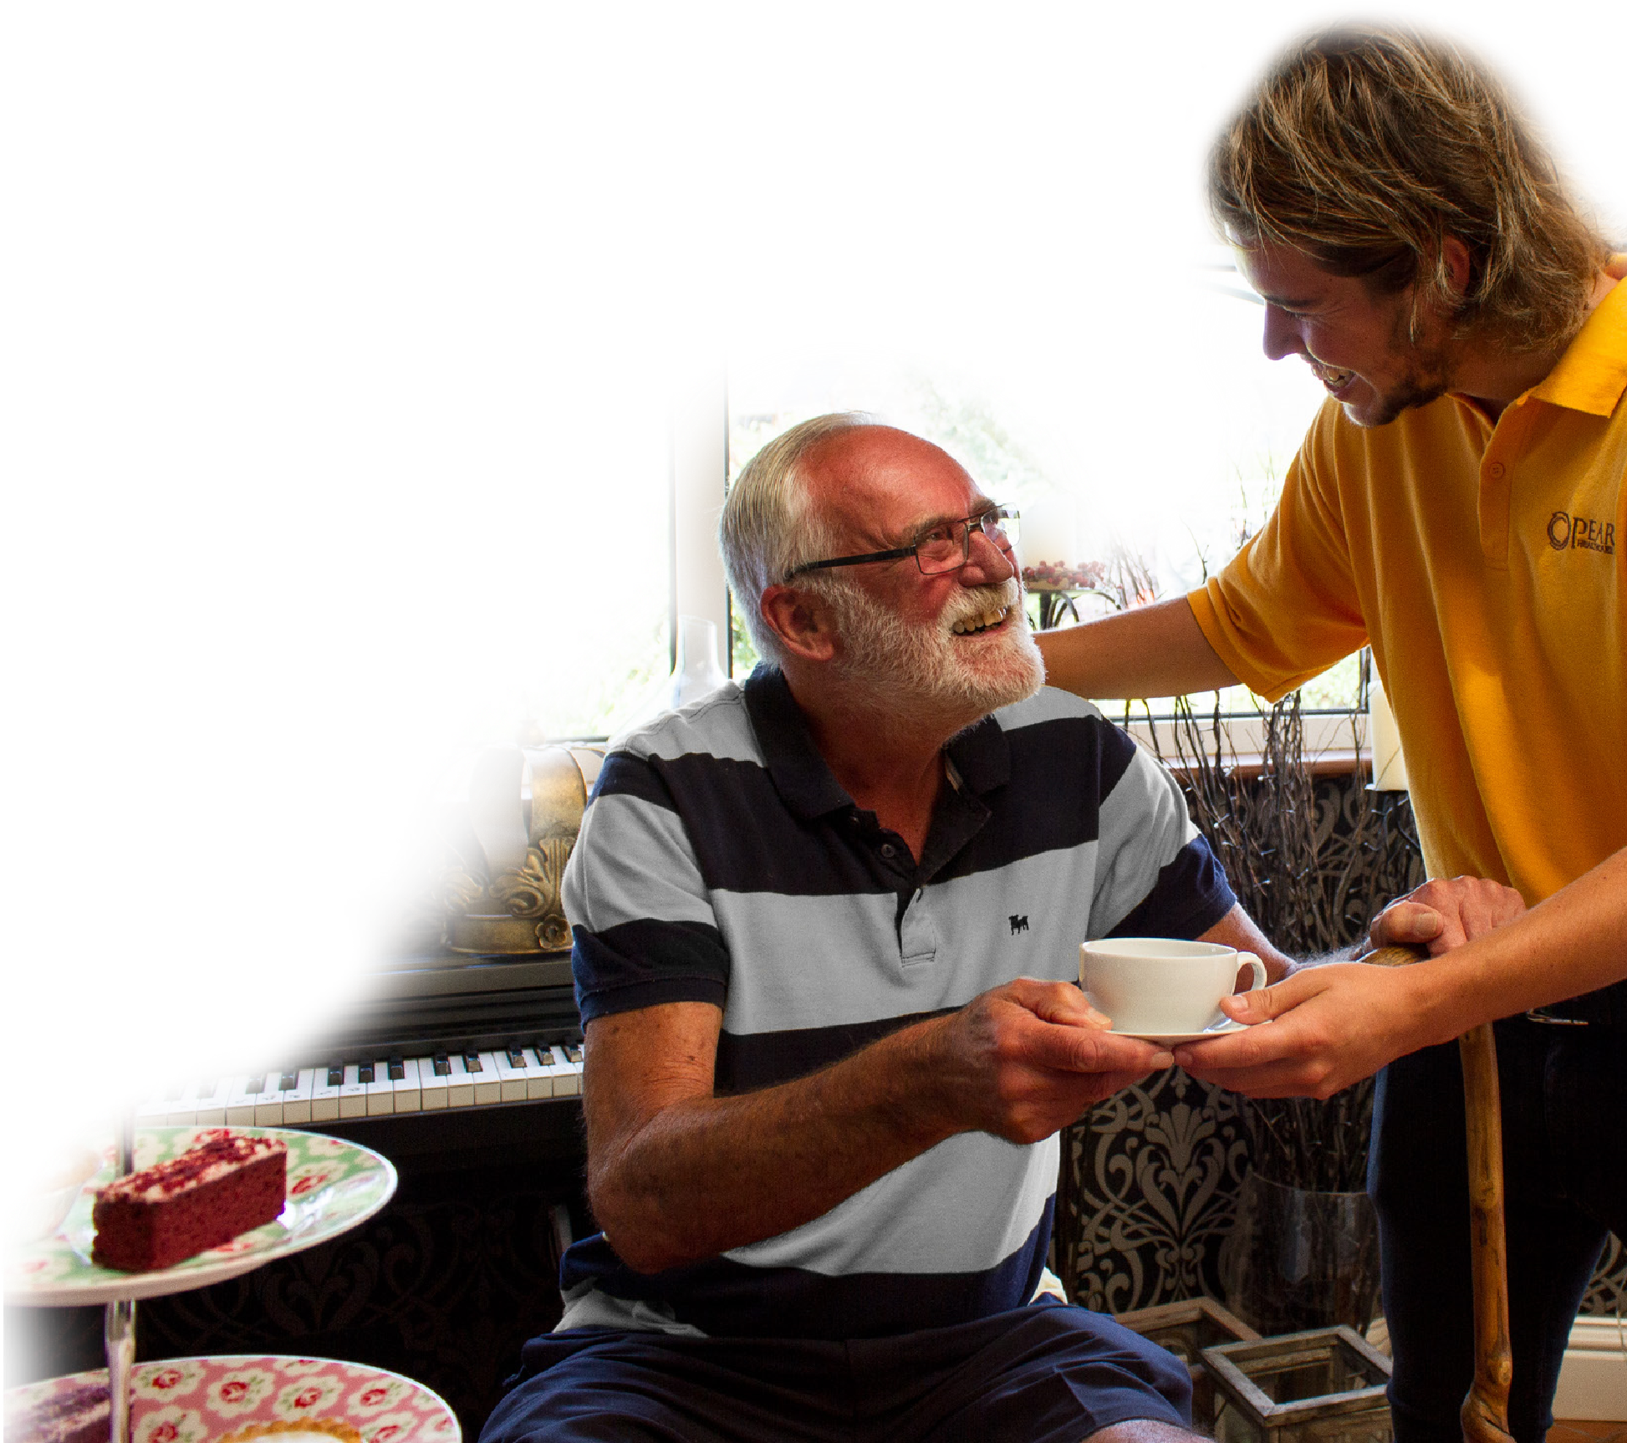

Location

Mandalay is situated in a tree-lined residential

road in the seaside town of Folkestone in Kent.

The home is within walking distance of the

town centre which is well served by a range of

high street shops and has its own theatre.

The Kent coastal region is rich with places

of historical and cultural interest, all within

easy reach of Mandalay, including Norman

churches, the Battle of Britain Museum and

Dover castle. The beautiful and historic city of

Canterbury with its centuries old cathedral is

just 18 miles away.

Comfort & Wellbeing

Mandalay has 45 en-suite rooms, all well-furnished

and equipped with TV & aerial points.

For your peace of mind there is a call system

in every room for residents to seek assistance

should they need it.

Residents are encouraged to bring with them

small items of furniture, pictures and ornaments to

personalise their rooms and help them feel more

at home.

In addition to the comfortable lounge we have a

bright dining room which looks out over a large

garden. The garden and courtyard areas are

wheelchair accessible.

Warm & Welcoming

We have an open visiting policy and visiting friends

and relatives are always made welcome. Visitors

are also welcome to stay for lunch or supper by

arrangement, should they wish.

Activities

Enjoy tailored activities such as gardening,

exercise, board games and quiz nights as well

as specialist activities like reminiscence and music

therapy. Outings include trips to garden centres,

the theatre and Christmas shopping trips.

Residents are the focal point of our service

provision. We ensure that they are fully

involved in the planning and delivery

of services, promoting their right

to dignity, privacy, choice and

independence.

Dementia Care

as

promoting

support

the

Round

clock

in

a

independence

possible

as

much

safe and comfortable environment. Using tailored

care plans and a person centered approach

we get to know our residents individual likes,

dis-likes and habits.

In addition to the home’s dedicated team of staff,

residents can access a range of healthcare and

wellbeing services who will

visit the home, including

GP, district nurses,

chiropodist and

hairdresser.